Local Government Act 1972

Notice of Annual Parish Meeting

For Berkswich Parish

All residents of Berkswich Parish are invited to the
Annual Parish Meeting
To be held on Tuesday 3 May 2022 at 7.00 pm
At Walton (Berkswich) Village Hall, Green Gore Lane, Walton on the Hill

Agenda

22/1 Welcome and introduction by Chair

22/2 Apologies

22/3 Approve the minutes of the meeting held on 4 May 2021

22/4 Chair’s Annual Report 2021/22

22/5 Annual Financial Statement

22/6 Matters raised by Parishioners

22/7 Close of meeting

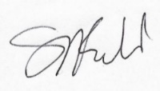
Sue Fullwood
Clerk/Responsible Financial Officer 26 April 2022

