Minutes of Berkswich Parish Council Meeting held on
Tuesday 5 April 2022 at 7.30 pm at Walton Village Hall

Present: Cllr Sue Francis (Chair), Cllr Malcolm Millichap (Vice Chair), Cllr Margaret Crossland, Cllr Graham Kilford, Cllr Tim Luker, Cllr Ann Millichap, Cllr Mike Pascoe, Cllr Ben Rowell and Cllr Alan Taylor

In attendance: Cllr Andy Cooper from Stafford Borough Council, Mrs Sue Fullwood as Clerk and 1 member of the public

1. Public questions

A member of the public attended the meeting to update with progress on the Information Hut at Milford. The Area of Outstanding Natural Beauty (AONB) team at Staffordshire County Council had been very supportive and were supplying clothing such as gilets, polo shirts and hats. They were also producing story boards to go inside the hut. Unfortunately, the storms earlier in the year had taken off a panel on the outside of the hut, which had revealed that the whole hut was covered in asbestos panels. It had therefore been decided that no-one should enter the hut and the hut would not be open in time for Easter, if at all this year. Support from volunteers had started to wane. Entrust had been asked to do a risk assessment and repair work, but there had been no activity for the past month. Cllr M Millichap suggested that the Parish Council should write to Stafford Borough Council asking that consideration be given that any funds from housing developments in the area could go to replacing the information hut. Resolved: Letter to be sent to SBC Action: Clerk.

The member of the public also asked for an update on 30 mph speed limit at Milford as it was in SCC’s budget for 2021/22 but nothing had been done. Resolved: Cllr Sue Francis to liaise with Cllr John Francis from SCC and provide an update. Action: Cllr Sue Francis.

The member of the public left the meeting at 7.40 pm.

22/044 To note apologies for absence – Apologies accepted from Cllr Caroline Pearson.

22/045 To record Declarations of Interest regarding items on the agenda – Cllr Kilford declared an interest in item 22/052 i. the Planning Appeal for Osborne House.

22/046 To approve minutes of the Council meeting held on 1 March 2022 – Resolved: Typo to be corrected on item 22/042 ii – partied to parties – then agreed as a true record.

22/047 Update on matters arising which are not agenda items

22/033 – Milford Project Fencing – there was now a Health and Safety Hazard as there was access to the pools. Resolved: Clerk to write to the landowner Action: Clerk.

22/036 – Engine Idling – Cllr Francis asked if anything had been received regarding the Clean Air Campaign. The Clerk confirmed that posters and a banner had been received and she had put some up around Berkswich School. Unfortunately some of the posters had been more business oriented and so weren’t suitable. Cllr Pascoe had noticed that the Select Bus was parking on The Rise again, but had it’s engine turned off so at least it wasn’t idling.

22/048 War Memorial Repairs – Cllr Taylor had measured the steps and had come up with two options for the railing to be installed: one option to have the railing to the side of the steps which could be awkward for people to reach; and one option to have holes drilled into the steps while repairs were already being done so that the railing could be easily reached. Cllr M Millichap proposed that the Council went with the second option with drilled holes, seconded by Cllr Luker and agreed unanimously. Resolved: Cllr Taylor to finalise specification and then liaise with Clerk to go out to tender. Action: Cllr Taylor/Clerk. The Chair thanked Cllr Taylor for his work on this so far.

22/049 Walton Coppice Tenders – Decision postponed to next meeting as only one tender had been received. It was agreed to go out to tender again for a short period. Feedback from one supplier had been that they were overwhelmed with work but would like the opportunity to tender in future. Resolved: Cllr Taylor to liaise with the Clerk to invite more companies to submit tenders before 3 May meeting. Clerk to seek further feedback from companies who had not submitted tenders. Action: Cllr Taylor/Clerk

22/050 Queen’s Platinum Jubilee
i Purchase of new equipment – Councillors had been out to visit play equipment in situ. It was agreed that the Kompan tender seemed to offer the best value. Cllr M Millichap proposed that the play equipment should be purchased from Kompan, seconded by Cllr Luker and agreed unanimously. Resolved: Clerk to send purchase order to Kompan and contact unsuccessful tenderers. Action: Clerk
ii Afternoon Tea Update – Cllr M Millichap updated the Council that the WI had agreed to decorate and set up the Village Hall and had three volunteers who would do the tea and coffees. Cllr A and Cllr M Millichap would supply the tea and coffee. The WI felt that under 40 attendees in such a large room would look empty. If there weren’t 40 places booked by 3 May meeting, it may need to be cancelled. The Clerk would need to arrange a minor correction in the Three Decker to clarify the start time. Action: Clerk
iii The Queen’s Green Canopy – planting a tree – Cllr Taylor had looked at four specialist tree nurseries but there weren’t any suitable oak trees available. Resolved: Planting to be done in October/November 2022. Cllr Crossland suggested that the Forest of Mercia had trees and they had a scheme to look after them too. Cllr Taylor agreed to get further information. Action: Cllr Taylor
Cllr Rowell asked about the proposal to rename the playing fields. Cllr Francis asked the Councillors to consider if the name should be changed before the next meeting as it may have special meaning for some people. Action: All Councillors

22/051 Financial Matters

Cllr Rowell asked about the breakdown of staffing costs. Cllr Francis confirmed that she checked the Clerk’s expenses and timesheet every month and that the other figures were generated by payroll. Resolved: Clerk to share detailed staffing costs with both the Chair and Cllr Rowell every month. The Clerk had started to receive the current account statement at her address and Cllr Rowell gave the passbook for the Stafford Railway Building Society to the Clerk to keep with other financial documents. Cllr Rowell suggested that there should be an annual review of bank signatories and said he would share a meeting cycle with the Clerk as an example of how to schedule things for review.

i To approve Bank Reconciliation and expenditure for February – Resolved: Unanimously approved.

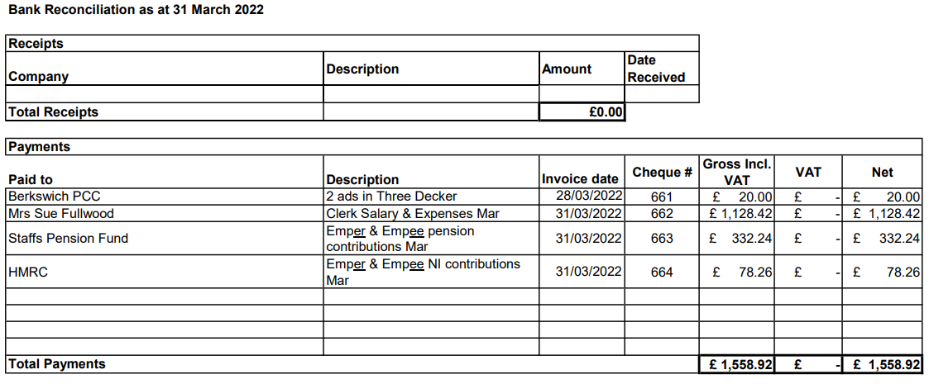

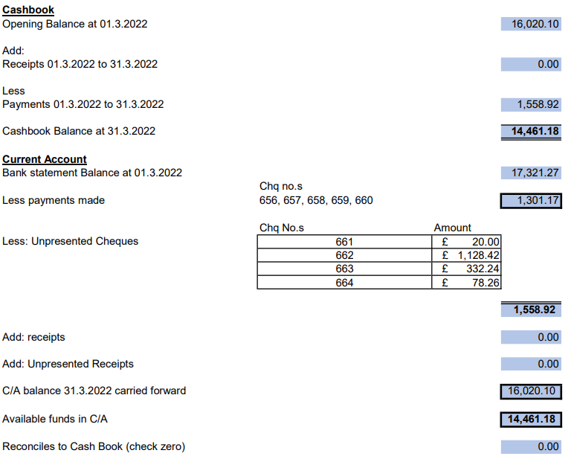

ii To approve budget report for February – Resolved: Unanimously approved.

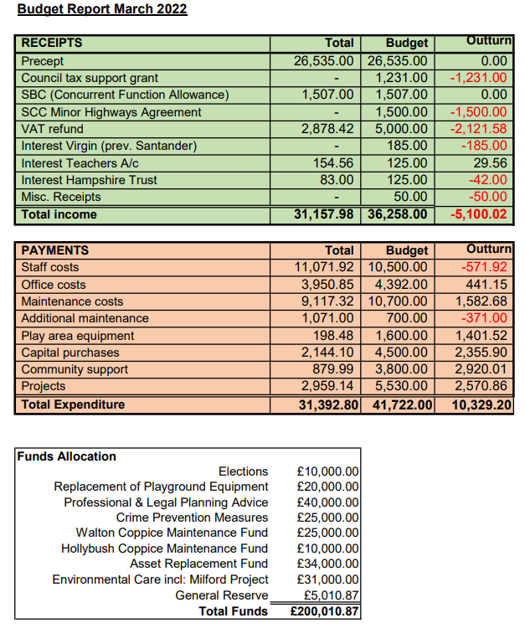

TGM had requested that the Council considered letting them increase the prices in their tender due to the rising costs of living, increases in fuel prices in particular. Various options were discussed. Resolved: Clerk to ask TGM to resubmit their tender with revised prices, asking them to bear in mind that the Parish Council could not increase the precept. Action: Clerk

22/052 Planning Matters

i Planning Application 21/33764/COU at Osborne House – Cllr Kilford stated that 3 out of 4 of the neighbours of this property objected to the plans, but they were not willing to put their concerns forward as the owner would see them which could cause bad feeling. Resolved: Clerk to write to SBC confirming that the Council’s previous comments stood and should be put forward to the Planning Inspectorate. Action: Clerk

ii Planning Application 21/35004/HOU and 21/35148/LBC at 14 The Village – the application was to replace concrete roof tiles with a roof more in keeping with the area. Resolved: Clerk to write to SBC to confirm that the Council support the applications. Action: Clerk

iii Planning Application 21/35350/FUL Land East of Milford Borehole Pumping Station. Resolved: Clerk to write to SBC to confirm that the Council have no comment on the application. Action: Clerk

22/053 Reports from other meetings
i Environment Group – Cllr Crossland had stood down as Chair of the group and going forward the Chair would be Cllr Luker. The group had met and were looking at two places at Hollybush Playing Fields for creating a wildflower strip. Resolved: Cllr Luker to ask for advice from Staffordshire Wildlife Trust at a cost of £200-300. TGM may be asked to do the planting.
A Bluebell Hollow resident had offered to help at Walton Coppice on a voluntary basis. Clerk to establish if the Council were covered for volunteers on their insurance policy. Action: Clerk.

ii Village Hall Council of Management – The AGM had been held on 30 March and there had been new trustees and a new Chairman. The Treasurer had given a comprehensive report. The number of clubs using the Hall was falling and the increase in the cost of living could make more clubs fold, but the Hall had financial reserves that could tide them over for a while. The Parish Council had use of a cupboard in the Bromage Room and would need to go through the files to see what could be disposed of. It could be a future project to contract someone to digitise records.

iii Trent Valley Collaboration Group – Berkswich Parish Council hosted the meeting on 11 March. The Chair thanked the Clerk for organising and supporting the meeting, and Cllr A and M Millichap, and Cllr Pearson for their donations of cakes for refreshments. Various topics had been discussed, but TVCG were very disappointed that SCC had promised a scheduled for gulley cleaning, but then said there wasn’t one.

22/054 Agenda items for the next meeting

The Annual Parish Meeting would take place on Tuesday 3 May 2022 at 7.00 pm at Walton Village Hall and Councillors should consider who they would like to be Chair and Vice Chair of the Parish Council for the next year.

The next Parish Council meeting would take place on Tuesday 3 May 2022 to follow on from the Annual Parish Meeting at Walton Village Hall. Agenda items agreed were: Survey of Trees in School Lane; Walton Coppice; Queen’s Platinum Jubilee afternoon tea; review of Standing Orders, Financial Regulations, Financial Risk Assessment and Asset Register.

The Chair thanked everyone for attending and closed the meeting at 8.55 pm.

