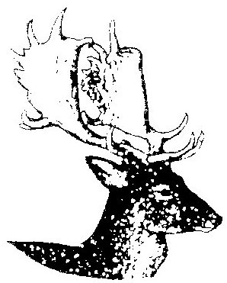
BERKSWICH PARISH COUNCIL

Minutes of Berkswich Parish Council Meeting held on
Tuesday 16 December 2021 at 7.00 pm at Walton Village Hall

Present: Cllr Graham Kilford, Cllr Alan Taylor, Cllr Caroline Pearson, Cllr Tim Luker

In attendance: Mrs Sue Fullwood as Clerk

As Cllr Francis and Cllr M Millichap were not present, Cllr Graham Kilford was nominated to be Chair by Cllr Pearson, seconded by Cllr Luker. Cllr Kilford welcomed everyone to the meeting.

- Public Questions

No members of the public were in attendance.

Agenda

21/180 To note apologies for absence

Apologies were received from Cllr Sue Francis (Chair), Cllr Malcolm Millichap (Vice Chair), Cllr Ann Millichap, Cllr Margaret Crossland, Cllr Mike Pascoe and Cllr Ben Rowell.

21/181 To record Declarations of Interest regarding items on the agenda

None.

21/182 Financial Matters

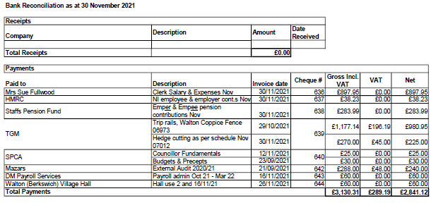

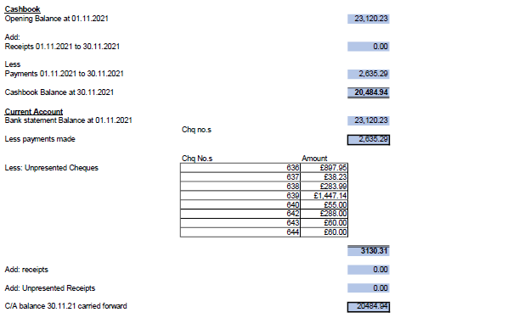
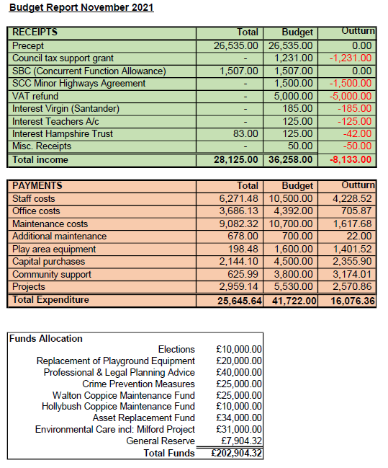

Resolved: The bank reconciliation, expenditure and budget report were agreed as accurate and approved.

21/183 Items for the agenda for the next meeting scheduled for Tuesday 4 January 2022

Engine idling on The Rise; Hollybush Playing Fields; review Financial Regulations

