BERKSWICH PARISH COUNCIL

Minutes of Berkswich Parish Council Meeting held on
Tuesday 2 November 2021 at 7.00 pm at Walton Village Hall

Present: Cllr Sue Francis (Chair), Cllr Malcolm Millichap (Vice Chair), Cllr Ann Millichap, Cllr Graham Kilford, Cllr Alan Taylor, Cllr Caroline Pearson, Cllr Margaret Crossland, and Cllr Mike Pascoe

In attendance: Cllr Andy Cooper of Stafford Borough Council, Mrs Sue Fullwood as Clerk and 12 members of the public

Cllr Francis welcomed everyone to the meeting.

1. Public questions

21/165 Walton Coppice Cllr Francis brought item 21/165 forward on the agenda as residents of homes on Bluebell Hollow which back onto Walton Coppice had been invited to attend discussions on the potential clearance of a 3m wide strip behind their fences. Cllr Francis and Cllr Taylor gave background on the Coppice, and that following controversy regarding greenfield land being used for the original housing development, the developers had donated Walton Coppice to Berkswich Parish Council along with £30k for its upkeep. There had been difficulty getting commitment from contractors to manage the area and the Council had been let down on two occasions. An ecological report had been commissioned from Staffordshire Wildlife Trust a few years ago, and this year a full tree survey had been undertaken, along with detailed surveys of trees T001 and T005, the large oak trees with Tree Preservation Orders at both ends of the Coppice.

When the Coppice had originally been planted, many trees had been planted too close together and were concentrated at the bottom near to properties, where they should have been spread up the bank. There was a proliferation of silver birch trees and sequential management would be needed over the next 50 years. The tree survey report recommended clearing a 3m strip of land, potentially increasing to 5m, and substituting the trees with new planting further up the hill where they were less likely to damage properties.

A member of the public asked if the hedgerow would definitely be cleared as they felt it offered security to the rear of their properties and that clearing the area would effectively be creating a pathway. It was felt that children from local schools would end up sitting along there. Resolved: The Council would take further advice regarding whether the hedge was salvageable and would investigate the possibility of hedge-laying and trying to regenerate the hedge. Action: Clerk/Cllr Taylor

A member of the public queried if all trees within the 3m strip would be cleared as some parts were absolutely beautiful and an asset to the homes on Bluebell Hollow. Cllr Taylor replied that there may be a case for keeping some of the trees and that ‘on the spot’ decisions would need to be made if the clearance went ahead.

Another member of the public was interested in the £30k budget and if maintenance would stop when that money ran out. Cllr Francis explained that the budget was topped up annually from the Parish Council’s precept. Cllr Francis added that she understood everyone’s security concerns and reassured people that the Parish Council did not want to cut down the hedge or trees if it was unnecessary.

One member of the public said that they had seen residents who had put gates in their back fences so that they could access the Coppice and that the wildlife was slowly disappearing because of people and dogs in there. Cllr Taylor replied that if the Parish Council have been made aware of people accessing the Coppice, they have written to the residents concerned to say that they cannot use gates to access the Coppice as it is Parish Council land.

Resolved: The Parish Council will keep relevant Bluebell Hollow residents up to date with future plans for Walton Coppice.

The 12 members of the public left the meeting at 7.30 pm.

Cllr Francis reported that the fence near to tree T001 was loose. Resolved: Clerk to ask TGM to repair the fence. Action: Clerk

21/161 To note apologies for absence – Cllr Tim Luker and Cllr Ben Rowell.

21/162 To record Declarations of Interest regarding items on the agenda - There were no declarations of interest.

21/163 To approve minutes of the Council meeting held on 5 October 2021 – Resolved: agreed as a true record.

21/164 Update on matters arising which are not agenda items

Hazardous Trees – There had been no update to the report status on the SCC website re the trees on Main Road and Brocton Lane, but the Clerk reported that the tree runners on Brocton Lane had been cut back.

Walton Coppice Trees T001 and T005 – The written report had now been received.

War Memorial Maintenance – Several quotations had been received and discussions took place regarding whether the memorial should be cleaned. Resolved: Cllr Taylor to prepare a specification detailing the exact requirements without cleaning and the Clerk to ask for revised quotes based on the new specification. The reattachment of the plaque should be included. Action: Cllr Taylor/Clerk

Telephone Box on Main Road – Colwich Parish Council had not provided a quote for work to the telephone box. Cllr Francis knew someone who would clean it up in return for a donation to charity. Resolved: Cllr Francis to liaise with the person and arrange for a donation from the Chairman’s fund. Action: Cllr Francis

Hollybush Playing Fields – The benches had been removed from the wooden play equipment.

21/165 Walton Coppice – see 1 above.

21/166 Parking on The Rise

An email had been received from a resident on The Rise regarding parking problems on The Rise at school drop off/pick up times which had seemed worse since the start of school year 21/22. There was a particular issue with a Select bus which parked on The Rise with its engine running for up to 45 minutes which caused an obstacle to other road users and polluted the air which was a traffic offence. Discussions took place over whether to contact the bus company, the school or the police. Resolved: Clerk to write to Walton High School asking if there was somewhere the bus could wait off the highway. Action: Clerk

21/167 Queen’s Platinum Jubilee – ideas for children adjourned to next meeting.

21/168 To approve Christmas Newsletter – Resolved: newsletter to be sent to Benhill Press for formatting. Action: Clerk

21/169 Financial Matters

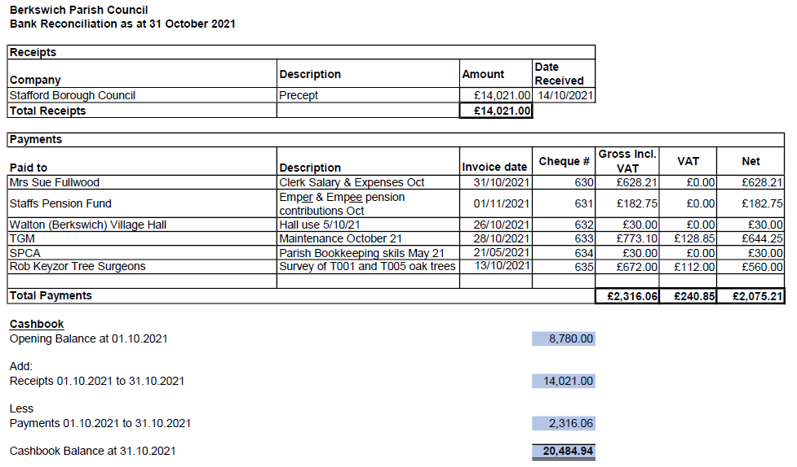

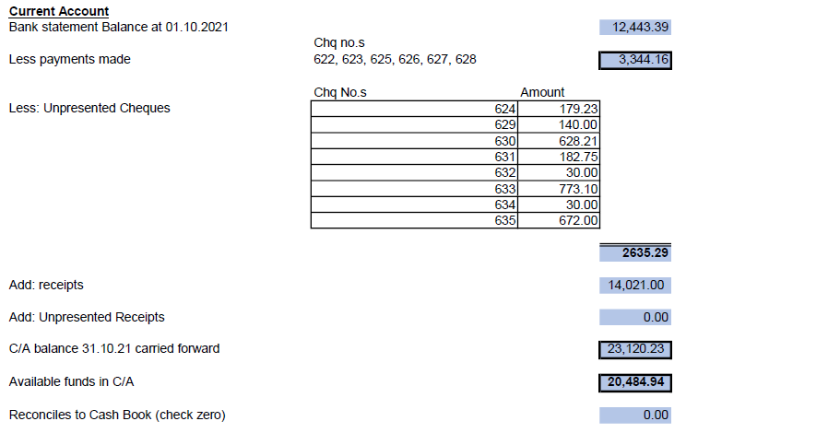
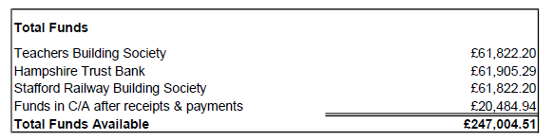
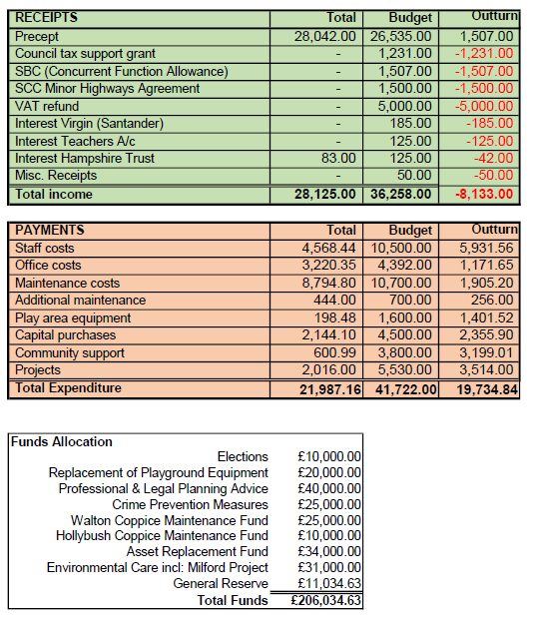
Resolved: The bank reconciliation, expenditure and budget report were agreed as accurate and approved.

21/170 Reports from other meetings
i Environment Group – Cllr Kilford reported that BT had decided to cut down two large mature silver birch trees down Green Gore Lane, and that contractors had cut down one tree but he had managed to stop them cutting down the second tree by sitting on the wall underneath it.
ii Village Hall Council of Management – The Village Hall had large reserves and the Council of Management had proposed that fees for groups using the Hall should be reduced. The Parish Council agreed to back Cllr Pascoe whichever way he decided to vote. The Chairman of the committee was leaving and had called for anyone to replace him, no-one had come forward so the Chairman had agreed to stay for one further meeting.

21/171 Agenda items for the next meeting

The next meeting would take place on Tuesday 7 December 2021 at 7.30 pm at Walton Village Hall. No agenda items were agreed.

Exclusion of the Public - The Chair moved: That the public were excluded from the meeting for the item of business below which involved the likely disclosure of exempt information as defined in the paragraphs of Part 1 of Schedule 12A (as amended) of Local Government Act 1972.

21/172 Clerk’s Salary Scale

The Clerk left the meeting while discussions took place. Resolved: having reviewed the NALC guidance regarding salary scales, the Parish Council agreed to amend the Clerk’s salary scale from LC1 (7-12) to LC2 (29-32) with effect from 1 November 2021. Action: Clerk

The Chair thanked everyone for attending and closed the meeting at 8.30 pm.

