Minutes of Berkswich Parish Council Meeting held on
Tuesday 3 May 2022 at 7.30 pm at Walton Village Hall

Present: Cllr Sue Francis (Chair), Cllr Malcolm Millichap (Vice Chair), Cllr Margaret Crossland, Cllr Graham Kilford, Cllr Ann Millichap, Cllr Caroline Pearson, Cllr Ben Rowell and Cllr Alan Taylor

In attendance: Cllr Andy Cooper from Stafford Borough Council, Mrs Sue Fullwood as Clerk and one member of the public

Cllr Francis welcomed everyone to the meeting.

1. Public questions – none.

22/055 Election of the Chair of the Parish Council – Cllr M Millichap proposed that Cllr Sue Francis should continue as Chair, seconded by Cllr Taylor and agreed unanimously. Resolved: Cllr Francis to continue as Chair of Berkswich Parish Council.

22/056 Election of the Vice-Chair – Cllr Francis proposed that Cllr M Millichap should continue as Vice-Chair, seconded by Cllr Taylor and agreed unanimously. Resolved: Cllr M Millichap to continue as Vice-Chair of the Parish Council.

22/057 To note apologies for absence – Apologies were accepted from Cllr Tim Luker and Cllr Mike Pascoe.

22/058 To record Declarations of Interest regarding items on the agenda – none.

22/059 Updates to Councillor’s register of interest forms – Cllrs M and A Millichap were no longer Directors of Signal8 in Hong Kong. Cllr Taylor was no longer employed by Stafford Borough Council. Action: Clerk.

22/060 Appointing representatives to:
- Environment Group – it was agreed for the group to continue as previously, with Cllr Luker as Chair with Cllr Taylor, Cllr Crossland and Cllr Francis as members.
- Village Hall Council of Management – Cllr M Millichap proposed that Cllr Pearson should be the Council’s representative for this meeting, seconded by Cllr Taylor and agreed unanimously.
- Trent Valley Collaboration Group (TVCG) – Cllr M Millichap proposed that Cllr Taylor should continue as representative for this meeting, seconded by Cllr Ann Millichap and agreed unanimously.

22/061 To approve minutes of the Council meeting held on 5 April 2022 – Resolved: agreed as a true record.

22/062 Update on matters arising which are not agenda items

22/036 – Engine Idling – Cllr Rowell had mentioned the Select Bus on The Rise at the Walton High School (WHS) Governors’ Meeting and the school had agreed to contact Select again. Cllr Rowell queried why Clean Air posters had not been put up on The Rise; the Clerk confirmed that the employee of SCC who had delivered the posters to her had said that she had delivered some to WHS directly. The Clerk would send information to Cllr Rowell. Action: Clerk

22/063 War Memorial Damage – The Clerk updated the councillors on the police investigation into the damage at the war memorial. The Clerk had contacted the Council’s insurance company and they had said that they would need two quotes for repairing the damage to compare. The Clerk had contacted some stonemasons to give quotes for the repairs. It was important that the repairs were done as quickly as possible so that the memorial was ready for Remembrance Day. Cllr M Millichap said that he knew of companies that were conservation experts and he would share the details with Cllr Taylor.

Cllr Taylor was still considering the handrail issue; if the handrail were in one piece it would be too large to transport in a car, so he was hoping to get a handrail that could be assembled and dismantled easily.

22/064 Walton Coppice Tenders – Three tenders had been received from Penkridge Arboriculture for £16,308; Rob Keyzor for £13,200; and one from ArB for £10,560, all including VAT. The Council considered costs, experience, timescales and compliance with the requirements set out in the invitation to tender. There would be no need to have the work done in stages as the tenders were substantially less than Cllr Taylor had expected. Cllr Taylor proposed that ArB should be awarded the contract, seconded by Cllr M Millichap and agreed unanimously. Cllr M Millichap thanked Cllr Taylor for all his hard work on this. Resolved: ArB’s tender to be accepted. Clerk to prepare purchase order and let unsuccessful tenderers know the outcome. Action: Clerk

22/065 Survey of Trees in School Lane – Cllr Taylor had prepared a specification for a condition survey of the trees opposite the houses on School Lane and the Clerk had sent it to local arboriculture companies. Tenders had been asked for by 16 May to allow for any extensions and it was hoped a decision could be made at the 7 June meeting.
22/066 Queen’s Platinum Jubilee
i Purchase of new equipment and damage to existing equipment – The purchase of new equipment was progressing. The Council hoped to hold a grand reopening for the park when the installation was complete.

An enquiry had been made through Facebook regarding exclusive hire of Hollybush Play Area for a child’s birthday party. The Council felt that hiring out the park could set a future precedent and that the Council was a non-profit making organisation. Resolved: The parent was welcome to use the park free of charge, but other residents would not be excluded as it was a public area. Clerk to respond to the parent. Action: Clerk

ii Afternoon Tea Update – Cllr M Millichap updated the Council that he now had 40 people who were definitely attending so the event would go ahead. The Mayor and Mayoress would be in attendance. Cllr M Millichap would be issuing numbered tickets and all the numbers would be placed into draw for a bottle of champagne, to be drawn by the Mayor. Cllr M Millichap would contact the caterers and confirm that the event was going ahead. Resolved: expenditure of up to £100 for decorations by the WI was approved, Cllr M Millichap to inform WI. Action: Cllr M Millichap Cllr Francis added that it would be good if councillors could pop in to show their support, even if they were not attending.

22/067 Hedges growing onto footpaths and roads – a resident had complained about the hedges in the area encroaching onto roads and footpaths. It was felt that hedges growing onto roads was not such an issue as it made vehicles slow down. It was felt that hedges growing over paths was a more serious issue as pushchairs and wheelchairs could not get through. The hedge at 19 Cedar Way along Holly Drive was felt to be quite obstructive. Resolved: Clerk to write to the homeowners and ask them to keep the hedge cut back for reasons above. Action: Clerk

22/068 Policy/Procedure Review
Cllr M Millichap proposed that the documents below should be reviewed annually at the Annual Meeting of the Parish Council in May unless a new version had been published by NALC or SPCA. Resolved: agreed unanimously, documents to be adopted as of 3 May 2022. The Clerk would prepare a meeting schedule to include policies for review using the example Cllr Rowell had shared. Action: Clerk
- Standing Orders – to be completed with time constraints: 3f – 5 mins; 3g – 5 mins; 3x – 2 hours and there can be a motion from the floor to continue for 15 mins.
- Financial Regulations – the Clerk had added an appendix to the regulations, a list of regular payments, to avoid meetings having to be held just to approve payments.
- Financial Risk Assessment
- Asset Register – Cllr Taylor suggested that the analemmatic sundial needed to be added to the register. Action: Clerk Cllr M Millichap said that the Chain of Office had not been valued for years and should be revalued. Cllr Francis agreed to wear the Chain of Office to the Queen’s Jubilee afternoon tea and then give the Chain of Office to the Clerk to arrange valuation. Action: Cllr Francis/Clerk

22/069 Financial Matters

Cllr Rowell pointed out that planned expenditure for 2022/23 aside from projects was only just covered by the precept. Cllr Francis said that the two large projects for 2022/23, playground equipment and work at Walton Coppice, were always planned to be paid for from reserves. Cllr Rowell said that the precept would need to be increased for 2023/24 as reserves wouldn’t last forever. Cllr Rowell suggested that a Finance Committee meeting should be set up to discuss how to split the withdrawals from the investment accounts.

TGM’s request for extra money to cover increased fuel costs was discussed. The maximum extra amount for the financial year would be £350 +VAT. Cllr M Millichap proposed that the Council accepted the request, seconded by Cllr Pearson. 6 Councillors voted for accepting the request and 2 voted against, therefore the motion was carried. Clerk to contact TGM to confirm. Action: Clerk

Cllr M Millichap should be removed from the list of bank signatories for the Teachers’ Building Society account. The Clerk would write to Teachers’ Building Society asking them to pay interest into the Virgin current account. Action: Clerk

i To approve Bank Reconciliation and expenditure for April – Resolved: Unanimously approved.

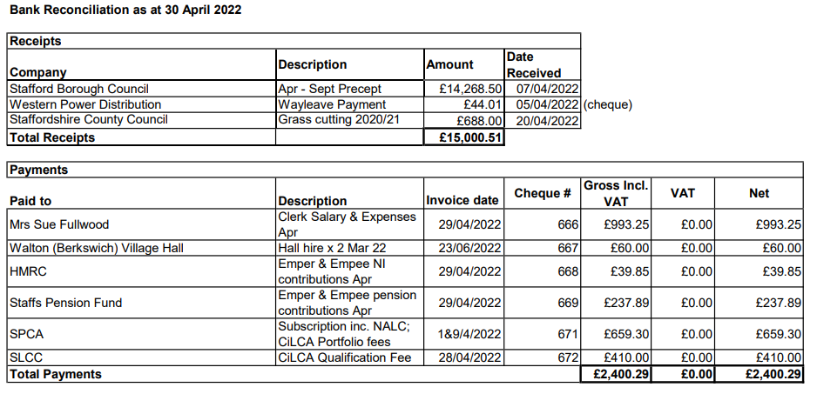
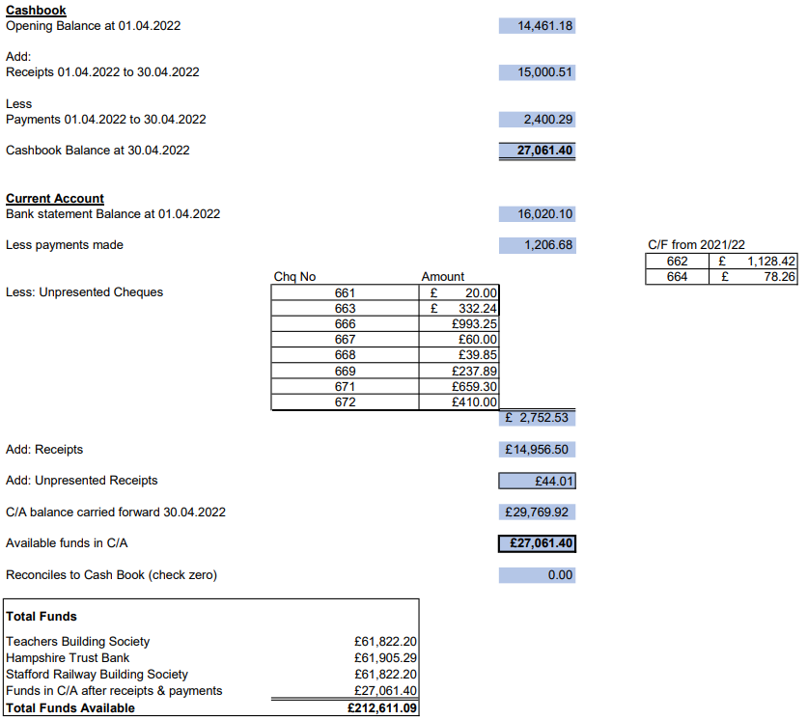
ii To approve budget report for April – Resolved: Unanimously approved.

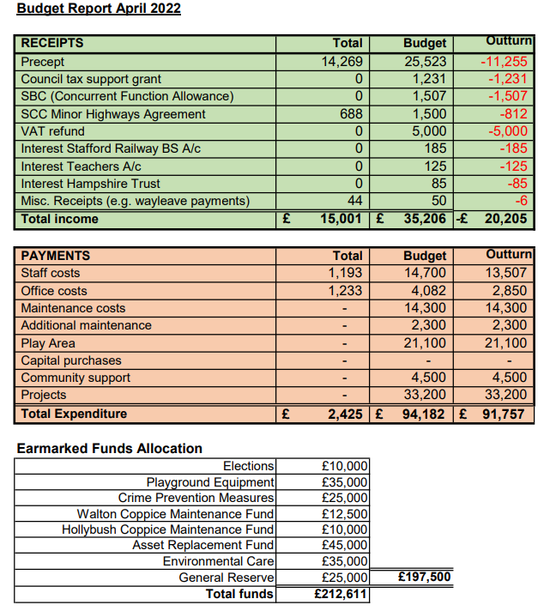

22/070 Reports from other meetings
i Environment Group – Cllr Tyalor reported that he and Cllr Luker had met with two potential volunteers at Walton Coppice. One of the volunteers had previously managed a nature reserve and they were both very keen, it was a very positive meeting.
ii Village Hall Council of Management – In Cllr Pascoe’s absence, Cllr Kilford said that there was nothing to report.

22/071 Agenda items for the next meeting

The next Berkswich Parish Meeting would take place on Tuesday 7 June 2022 at 7.30 pm at Walton Village Hall. Agenda items agreed were: Quotes for work to trees in School Lane.

The Chairman moved: That the public be excluded from the meeting for the item of business below which involves the likely disclosure of exempt information as defined in the paragraphs of Part 1 of Schedule 12A (as amended) of Local Government Act 1972.

22/072 Review Clerk’s Salary

Resolved: The Clerk would continue on the present salary.

The Chair thanked everyone for attending and closed the meeting at 8.50 pm.

