Minutes of Berkswich Parish Council Meeting held on
Tuesday 7 June 2022 at 7.30 pm at Walton (Berkswich) Village Hall

Present: Cllr Sue Francis (Chair), Cllr Margaret Crossland, Cllr Graham Kilford, Cllr Tim Luker, Cllr Caroline Pearson, and Cllr Alan Taylor

In attendance: Mrs Sue Fullwood as Clerk

Cllr Francis welcomed everyone to the meeting.

1. Public questions – none.

22/073 To note apologies for absence – Apologies were accepted from Cllr Ben Rowell, Cllr Ann Millichap, Cllr Malcolm Millichap (Vice Chair) and Cllr Andy Cooper from Stafford Borough Council.

22/074 To record Declarations of Interest regarding items on the agenda – none.

22/075 To approve minutes of the Council meeting held on 3 May 2022 – Resolved: agreed as a true record.

22/076 Update on matters arising which are not agenda items

22/036 – Engine Idling – Cllr Luker had been liaising with a contact at SCC who had said that schools should be the ones to take forward concerns about air quality. Cllr Luker had the name of someone who worked with schools and would try to contact her. It was felt that posters the pupils and students created themselves would have the most impact for parents.

22/064 – Walton Coppice Tenders – ArB were due to start work at Walton Coppice on 13 June and planting of the 2750 hawthorn whips would be delayed until Autumn so that they would not need to be watered over the Summer months.

22/067 – Hedges growing onto footpaths and roads - The Clerk had written to the homeowners and they had cut the hedge back.

22/068 iv – Asset Register - Cllr Francis passed the Chain of Office to the Clerk to be revalued and professionally cleaned at an independent jeweler if possible. Action: Clerk

22/077 Financial Matters

- To receive and note the Annual Internal Audit Report for 2020/21
Resolved: The report was received and agreed unanimously.

- To approve the Annual Governance Statement for 2020/21
Resolved: The Annual Governance Statement was received and agreed unanimously. Cllr Francis and the Clerk signed the statement.

- To approve the Accounting Statements for 2020/21
Resolved: The Annual Governance Statement was received and agreed unanimously. Cllr Francis and the Clerk signed the statement. The Clerk to send the documents to Mazars LLP, publish them on the website and post the notices. Action: Clerk

- To approve Bank Reconciliation and expenditure for May – Resolved: Unanimously approved.

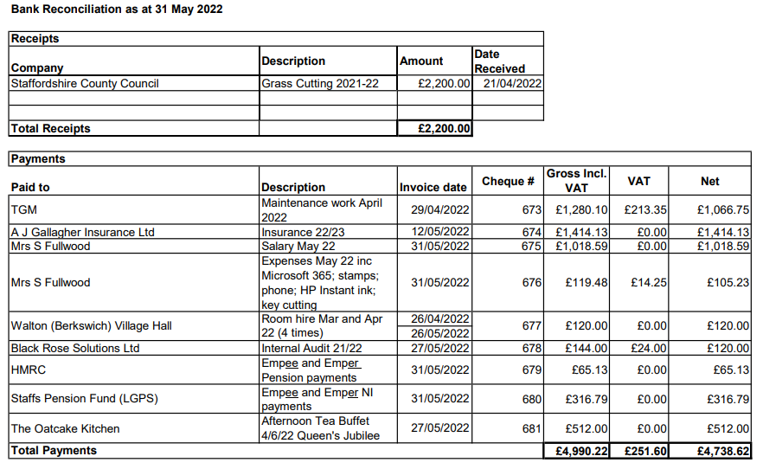

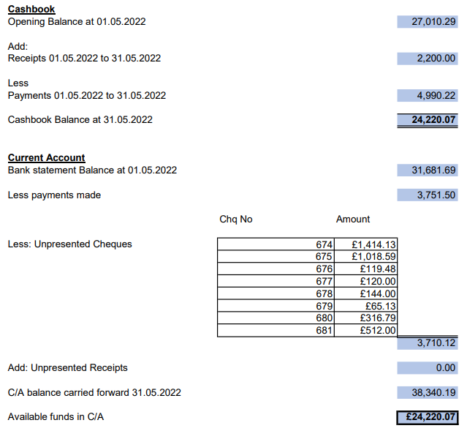

- To approve budget report for May 2022 – Resolved: Unanimously approved.

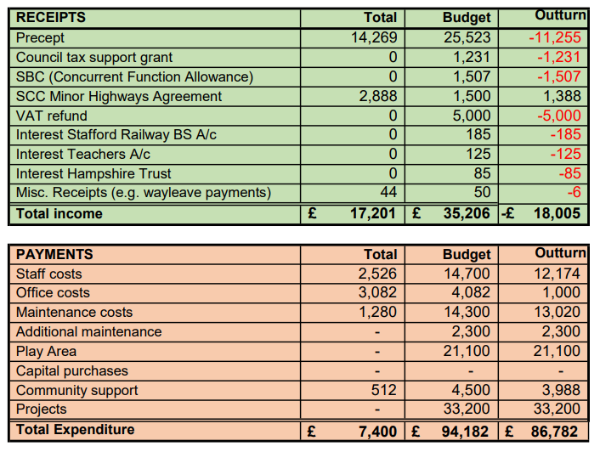

- To agree withdrawal of funds from short-term investment account

The Finance Working Group recommended that Council agree to the full £35,226.83 for the play equipment to be installed by Kompan in June 2022 should be withdrawn from the Hampshire Trust account due to the low interest rate on the account. Resolved: Unanimously approved. Clerk to establish withdrawal process. Action: Clerk

22/078 War Memorial Damage Update – The Clerk had received the details of the driver of the vehicle that had hit the war memorial from Staffordshire Police and had forwarded them to the Council’s insurers. Two quotes for repairs had been received and sent to the insurers and the Clerk was waiting for a response. If the Clerk had not had a response before the next meeting, she should chase the insurers. Action: Clerk

22/079 Quotes for Survey of Trees in School Lane – Only one tender had been received, therefore further quotes would be requested. Cllr Taylor had spoken to one contractor who had said they would quote, but nothing had been received yet. Cllr Taylor agreed to ask ArB to do a quote for the survey while they were working at Walton Coppice. Action: Cllr Taylor

22/080 Queen’s Platinum Jubilee
i Afternoon Tea Review – The event had been a success and everyone seemed to enjoy themselves. The WI (including Cllr Francis) had excelled at decorating the Hall and serving the guests. The Food from The Oatcake Kitchen had been excellent. One lesson for future events was that more people should be involved in planning from the start in case of last-minute changes. SCC Cllr John Francis had provided music. The Mayor and Mayoress had attended. They stayed for most of the event and spent time chatting with the residents. Cllr Taylor proposed that a thank you card should be sent to Cllr M Millichap for all his organisation for the event – agreed unanimously. Action: Cllr Francis Cllr Francis proposed that a thank you letter should be sent to the WI for all their help – agreed unanimously. Action: Clerk

Cllr Pearson proposed that flowers should be sent to Cllr A Millichap when she was home from hospital – unanimously agreed. Action: Cllr Pearson

ii Play Equipment Update – Purchase of New Equipment – Kompan were due to start work on 20 June and the Clerk was waiting for a date for a pre-start meeting. The Clerk would be on annual leave when work started and had given keys to Cllr Francis and Cllr Pearson.

iii Plans for reopening event – A discussion was had over the best date to hold a reopening event for Hollybush Playing Fields. Kompan had said that work would be complete and the inspection done by 17 July, the last Sunday before the school holidays – Resolved: the event to be arranged for 17 July from 12pm – 2pm. Residents would be invited to bring their own picnics. The Clerk should book a face painter for two hours - Cllr Taylor agreed to source a gazebo for her to work under and to erect it on the day. Action: Clerk/Cllr Taylor The Clerk would try to source an ice cream van to park outside the playing fields. Action: Clerk

22/081 Policy/Procedure Review

- Code of Conduct – agreed unanimously
- Publication Scheme – agreed unanimously
- Freedom of Information Policy – agreed unanimously
- Data Protection and Information Security Policy – agreed unanimously
- Complaints Procedure – agreed unanimously

All policies/procedures agreed with immediate effect. Clerk to publish on website. Action: Clerk

22/082 Councillor Vacancy – Cllr Mike Pascoe had resigned during May with immediate effect. A discussion took place regarding potential residents who could be co-opted. It was agreed that another councillor from Milford would be beneficial. Resolved: Cllr Kilford to ask a specific Milford resident if he would like to be on the Parish Council. Action: Cllr Kilford

22/083 Planning

- Planning application at Brookside, 23 Main Road – Cllr Taylor proposed a response as follows: Berkswich Parish Council has no objection in principle to extending this early 20th century dwelling and considers that the proposed design will enhance the appearance of the property when seen from Milford Road. The Council is concerned however that the new wing will be located very close to the mature trees along the eastern boundary of the site. Berkswich Parish Council defers to the advice of your Council's tree officers in this matter and would support refusal of permission if a risk of root damage during construction leading to loss of the trees and harm to local amenity were to be confirmed. Resolved: Agreed unanimously. Clerk to write to SBC. Action: Clerk

22/084 Reports from other meetings

i Environment Group – One of the new volunteers had given feedback on the risk assessment and suggested a ‘buddy’ system, so that if a volunteer didn’t return at the time planned their buddy could raise the alarm. A meeting had been arranged, but the volunteers had had to postpone – Cllr Taylor would try to rearrange the meeting ASAP.
Cllr Taylor would start to look again for a suitable tree to plant for the Jubilee at the end of July.

ii Village Hall Council of Management – Cllr Pearson had attended the meeting and was surprised to be asked to sign to be a trustee, but had signed anyway. Rates for room hire would be staying the same for 2022/23. Ideas had been asked for to encourage young people to use the Hall. The NHS and the National Pre-diabetic Association had both made bookings and paid up-front. Wifi was now up and running at the Hall and charges would be made for its use on a pay as you use basis.

22/085 Agenda items for the next meeting

The next Berkswich Parish Meeting would take place on Tuesday 5 July 2022 at 7.30 pm at Walton (Berkswich) Village Hall. Agenda items agreed were: Quotes for work to trees in School Lane; Clean Air Campaign; and Milford Fencing.

The Chair thanked everyone for attending and closed the meeting at 8.40 pm.

