BERKSWICH PARISH COUNCIL

Notice of an Extraordinary Meeting of the Council
Thursday 13 October 2022 in Walton (Berkswich) Village Hall,
Green Gore Lane, Walton on the Hill at 7.00 pm
Contact: Sue Fullwood, Clerk at berkswichclerk@gmail.com
or on 07871 645232

- Public Questions

Residents are welcome to bring matters to the Parish Council’s attention within the meeting. If a detailed response is required it would be helpful for the Clerk to receive your questions in writing, preferably 5 days before the meeting.

Agenda

22/124 To note apologies for absence

22/125 To record Declarations of Interest regarding items on the agenda

22/126 To approve expenditure for work on the War Memorial

22/127 To agree agenda items for the next meeting on Tuesday 1 November 2022 at 7.30 pm

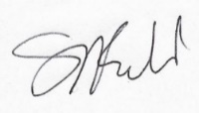
Signed Date: 7 October 2022

