Minutes of Berkswich Parish Council Meeting held on
Tuesday 4 October 2022 at 7.30 pm at Walton (Berkswich) Village Hall

Present: Cllr Sue Francis (Chairman), Cllr Malcolm Millichap (Vice Chairman), Cllr Ann Millichap, Cllr Graham Kilford, Cllr Tim Luker, Cllr Caroline Pearson and Cllr Ben Rowell

In attendance: Cllr Andy Cooper from Stafford Borough Council, Mrs Clare Blake-Barton as a prospective councillor and Mrs Sue Fullwood as Clerk

Cllr Francis welcomed everyone to the meeting.

1. Public questions – none.

22/101 To note apologies for absence – Apologies were received from Cllr Alan Taylor as he had been away; and from Cllr Margaret Crossland as her dog was unwell.

22/102 To record Declarations of Interest regarding items on the agenda – Cllr Francis declared an interest in item 22/120 i as she was joint owner of the property nextdoor. Cllr Francis would not join in discussions on this item.

22/103 To approve minutes of the Council meeting held on 6 September 2022 – Resolved: agreed as a true record.

22/104 Update on matters arising which are not agenda items

War Memorial – Cllr M Millichap asked for an update on the War Memorial repairs and the Clerk confirmed that Midland Masonry had been in touch and had spoken to Cllr Taylor on 3 October regarding extra work including a handrail. Cllr Taylor would discuss the work with them in detail when he was back at home. Action: Cllr Taylor

RoSPA report - TGM had greased the bearings on the roundabout and sent a quote to remove the covers, clean and re-grease the bearings for £375 +VAT. It was agreed to leave the work for the time being as the greasing had improved the movement of the roundabout.

Cllr Rowell asked if the Hampshire Trust Bank change of signatories form had been submitted; the Clerk confirmed that she now had all the necessary information and would send it to HTB the next day.

A resident had raised an issue regarding the trip rails along Brocton Lane. They were broken and rotting and she felt that they could be hazardous to those driving and walking along the lane, particularly as the nights draw in. Clerk to ask TGM for a quote for repairing and replacing the trip rails. Action: Clerk

22/105 Councillor Vacancy – Mrs Barton-Blake was invited to introduce herself to councillors. Resolved: Cllr M Millichap proposed that Mrs Barton-Blake be co-opted to the Council, seconded by Cllr Pearson and unanimously agreed. All attendees gave brief introductions to Cllr Barton-Blake.

22/106 Survey of Trees in School Lane – The tree survey report had been received from Rob Keyzor Tree Surgeons and recommended several trees were felled or pruned within 6 and 12-month periods. Resolved: Clerk to ask for two quotes from local companies: one for the work necessary within 6 months; and one for all the work recommended. Action: Clerk

22/107 Queen’s Green Canopy – the tree planting at Hollybush Playing Fields would still go ahead, but would now be in memorial of HM Queen Elizabeth II. Cllr Taylor was still looking for a suitable oak tree.
22/108 Remembrance Sunday – Discussions took place around who would place a poppy wreath on behalf of the Parish Council and where. Resolved: Cllrs Millichap would place a wreath on the War Memorial at Weeping Cross. Clerk to order one wreath. Action: Clerk

22/109 Holdiford Road Signalisation – Cllr Francis said that she would not be joining in discussions as it was County Cllr John Francis who had raised the issue initially. Councillors had never seen an accident in that area, but there had been some incidents where vehicles had met on the bridges and refused to give way. There were concerns about the synchronisation of the lights and the possibility of vehicles being stuck between the two sets of lights, but SCC and AMEY had given assurance that that would not happen.

22/110 Clean Air Campaign – Cllr Luker had emailed the teacher at WHS and had a very enthusiastic response, but then had heard nothing for 2 weeks. Cllr Rowell had noticed that the new Select Bus was not parking on the school car park and had spoken to the Executive Business Manager at WHS and asked them to tell the Select Bus to leave their engine off.

22/111 Reduction in the number of meetings – Discussions took place around how many meetings annually would be best for the Parish Council. Cllr Kilford confirmed that the charge for room bookings in 2023 would remain £30 per booking. Resolved: it was agreed to drop to 10 meetings per year, missing January and August. Action: Clerk

22/112 Parish Newsletters – The Council would save money from printing and delivery costs if the newsletters were published online. Cllr M Millichap proposed that one last newsletter was printed for Christmas, asking people to sign up to a mailing list to receive email notification when a newsletter was published online. All councillors present were in agreement with this, apart from Cllr Kilford who abstained.

22/113 Fencing at Milford – The Clerk had chased the landowner and received a positive response to say work would be completed over the next few weeks. Work had been started, but there were still areas where the fencing could be improved. Resolved: Clerk to chase the landowner again if no further progress during w/c 10 October 2022. Action: Clerk

22/114 Telephone Box – Cllr Pearson raised that the telephone box could use a repaint as it was going rusty, and that an additional shelf would be useful. Clerk to contact the Brocton Clerk to ask who had painted their box. Cllr Kilford suggested that BT might have someone that they subcontracted to. TGM to be asked if they would undertake the work and if so, what they would charge. Action: Clerk

22/115 Tree growing near to The Crescent – A tree, thought to be a staghorn tree, had been planted in the grass at the Crescent. It was not feasible to leave the tree there as it could potentially block the view of the road as it grows and it would be setting a precedent. Resolved: Clerk to write to nearest homeowners, asking them to move it, or suggest that the Council moves it to Walton or Hollybush Coppice. Action: Clerk
22/116 Data from Speed Indication Devices – Councillors had received the reports from the SIDs and agreed that they were a successful tool in slowing down traffic through the two villages. 714,489 incoming vehicles and 655,143 outgoing vehicles had passed the SIDs in one year. Over 98% of vehicles were going through at less than 40mph. Cllr Francis suggested looking at devices that flashed at people speeding for the Brocton Road, so that they could be placed on bendy roads. Resolved: Clerk to investigate possibilities. Action: Clerk

22/117 Plans for 2023/24 – Cllr Francis asked councillors to consider projects they would like to undertake and bring them to the next meeting. Action: All

22/118 Financial Matters

- Preliminary Budget Figures for 2023/24 – Cllr Rowell suggested that the maximum precept increase the Council should demand was 8%. The Clerk had prepared two draft budgets: one where the precept covered all potential costs for 2023/24; and one where reserves were used to bring the precept increase down to 8%.

- Bank Reconciliation and expenditure for September 2022 – Resolved: Unanimously approved.

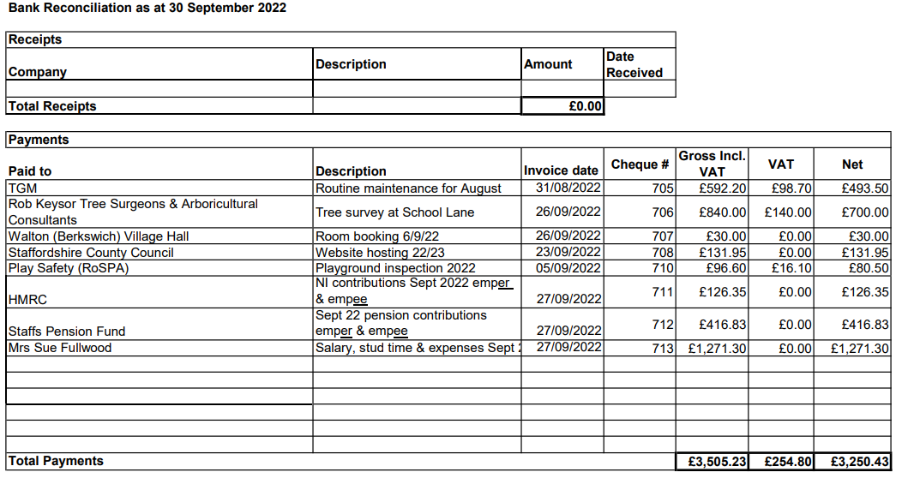
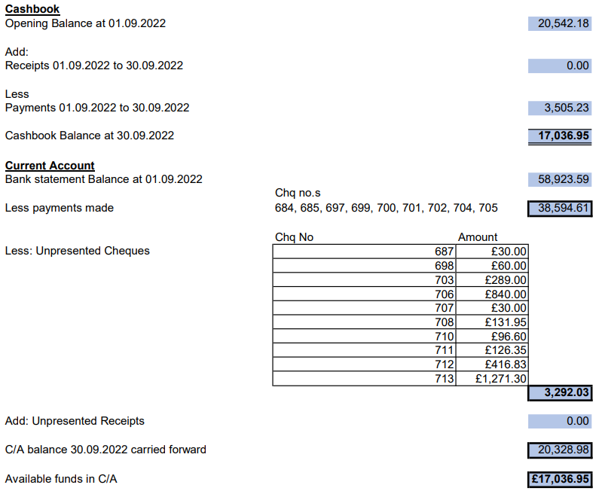

- budget report for June, July and August 2022 – Resolved: Unanimously approved.

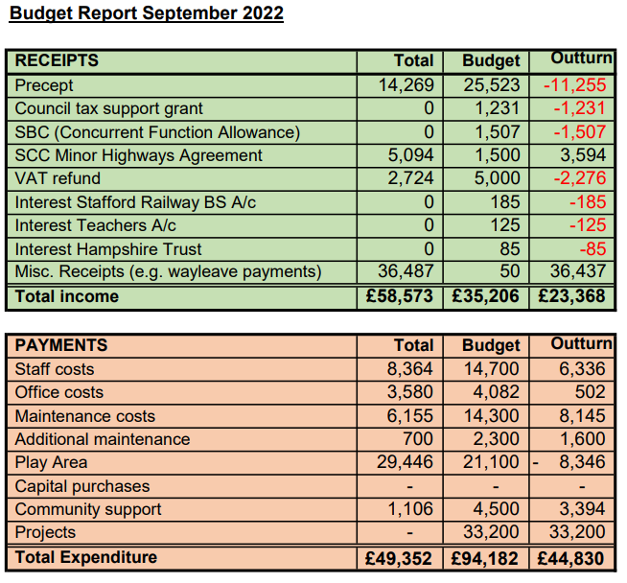

22/119 Policy/Procedure Review

- Disciplinary Policy
- Grievance Policy
- Health and Safety Policy
- Equality and Diversity Policy
- Training and Development Policy

Resolved: all policies were agreed unanimously. Clerk to upload the policies onto the website. Action: Clerk

22/120 Planning

- 22/36207/HOU 198 Main Road – Council agreed with Cllr Taylor’s proposed response as follows: BPC has no objection to the proposed alterations and extensions to this property which adjoins the Cannock Chase AONB. The Council supports the applicants' desire to improve the thermal performance of the dwelling but is concerned that visually the superimposition of PV panels on the south facing roofline will look like a clumsy afterthought, and that their glossy reflective surface will be intrusive in views from the AONB. BPC suggest that the impact of the PV panels be mitigated by amending the application to position them flush within the tile line.

22/121
- Environment Group – the two volunteers now had their own keys for Walton Coppice. They would be moving to Uttoxeter, but would still continue working at Walton Coppice. As a H&S measure, the volunteers would text the Clerk’s mobile phone when they would be working on site and when they were safely off the site again. Cllr Luker was trying to find a suitable date for all members to survey the Holdiford Road area.
- Village Hall Council of Management – The meeting scheduled for 28 September had been cancelled. Cllr Francis, Cllr Pearson and the Clerk had started to clear the cupboard at the Village Hall.

22/122 Agenda items for the next meeting

The next Berkswich Parish Council Meeting would take place on Tuesday 1 November 2022 at 7.30 pm at Walton (Berkswich) Village Hall. Agenda items agreed were: fencing at Milford; telephone box; Queen’s Green Canopy; planning for next year; clean air campaign; School Lane Trees; tree growing near to The Crescent.

Exclusion of the Public - The Chair moved: that the public be excluded from the meeting for the item of business below which involves the likely disclosure of exempt information as defined in the paragraphs of Part 1 of Schedule 12A (as amended) of Local Government Act 1972.

22/123 Evaluation of Clerk’s Role – Resolved: It was agreed that the Clerk’s role should be evaluated by SLCC Consultancy and that pay protection would apply if the outcome was a lower scale.

The Chair thanked everyone for attending and closed the meeting at 8.55 pm.

