Minutes of Berkswich Parish Council Meeting held on
Tuesday 7 March 2023 at 7.30 pm at Walton (Berkswich) Village Hall

Present: Cllr Sue Francis (Chair), Cllr Malcolm Millichap (Vice Chair), Cllr Ann Millichap, Cllr Alan Taylor, Cllr Tim Luker, Cllr Graham Kilford, Cllr Caroline Pearson, Cllr Ben Rowell and Cllr Margaret Crossland.

In attendance: Three members of the public including two as prospective councillors to observe the meeting, Colin Manning, Farming in Protected Landscapes Officer from SCC, Cllr Andy Cooper from SBC and Mrs Sue Fullwood as Clerk.

Cllr Francis welcomed everyone to the meeting.

1 Public session

23/22 30mph Speed Limit on Brocton Road, Milford

A member of the public from Brocton Road raised an issue that had been previously discussed. County Councillor John Francis had said that money for the change in speed limit from 40mph to 30 mph had been in the budget for 2020/21, but nothing had happened since then. The member of the public had emailed Cllr J Francis to see what had happened and it seemed that the waters had been muddied within SCC because Cllr J Francis had asked for a 7-tonne weight limit to be changed at the same time. The member of the public asked for support on the issue from the Parish Council as motorbikes travelled along the road exceeding 70mph, children and families were often crossing the roads to get to local facilities and he believed that 5 deer had been killed already in 2023 in that area.

It had been suggested by an SCC Cabinet Member that to help with budgetary constraints the Parish Council could contribute some money towards signage, etc. Cllr Malcolm Millichap felt that it would not be a good idea for the Parish Council to provide any service that SCC were responsible for. Cllr Rowell felt that if necessary, the Parish Council should financially support the speed reduction. Cllr Malcolm Millichap suggested that Brocton Parish Council may be interested in doing a joint letter to SCC. Resolved: Clerk to prepare a draft letter and contact the Brocton Clerk to discuss sending it jointly; and the Parish Council would look again at flashing speed camera for the area. Action: Clerk.

The member of the public left the meeting at 7.45 pm.

23/17 Opportunities for local landscape projects

Colin Manning from SCC introduced himself to the meeting. He confirmed that Defra had now extended funding to the end of 2025 and that any landowners can apply. The grant application for Walton Coppice had met four of the project aims and had been successful. Grant applications for over £5000 were considered by a panel from National England, Staffordshire Wildlife Trust, etc. Projects needed to be based near the AONB, the boundary was around 1km away, but was flexible depending on the project.

Cllr Malcolm Millichap asked if an allotment project would fit into the scheme – Mr Manning said it probably wouldn’t, but to send information through to him and he would look at it. Cllr Ann Millichap asked if a scheme at Jacob’s ladder to reduce the amount of mud would work – Mr Manning said that it would be unlikely as it was a legal right of way and they couldn’t give money for projects that were the legal responsibility of another body.

Cllr Francis thanked Mr Manning for attending and he left the meeting at 8.00 pm.

23/18 To note apologies for absence – none.

23/19 To record Declarations of Interest regarding items on the agenda – None.

23/20 To approve minutes of the Council meeting held on 7 February 2023 – Resolved: agreed as a true record.

23/21 Update on matters arising which are not agenda items

Retained EU Law (Bulldozer) Bill – Cllr Luker had drafted a letter to be sent to Kemi Badenoch MP in her role as Secretary of State for Business and Trade and to Thérèse Coffey MP in her role as Secretary of State for the Environment, Food and Rural Affairs. Resolved: Cllr Luker’s letter was agreed and the Clerk would arrange for it to be sent to both MPs. Action: Clerk.

Memorial Tree Planting for HM Queen Elizabeth II – Cllr M Millichap had been unable to attend and expressed his gratitude to those Councillors who did attend.

23/22 30mph Speed Limit on Brocton Road, Milford – see first item above.

23/23 Plans for Picnic for Coronation of King Charles III – The Clerk had bought card crowns, stick-on jewels, games and prizes for the event and had arranged to borrow tables and chairs from the Village Hall. Cllr M Millichap was trying to contact the Mayor to invite them to the picnic.

23/24 Financial Matters

- Bank Reconciliation and expenditure for February 2023 – Resolved: Agreed unanimously.

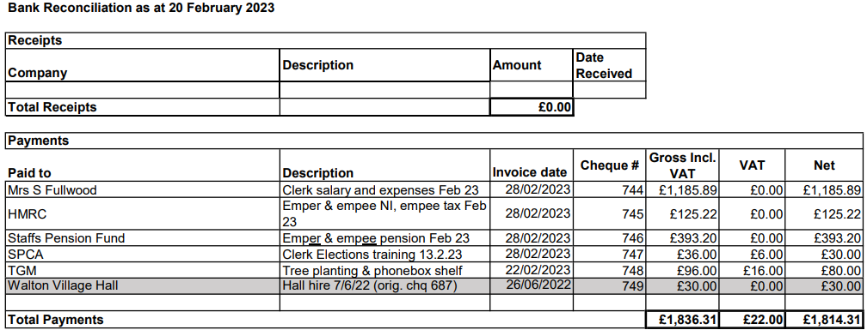

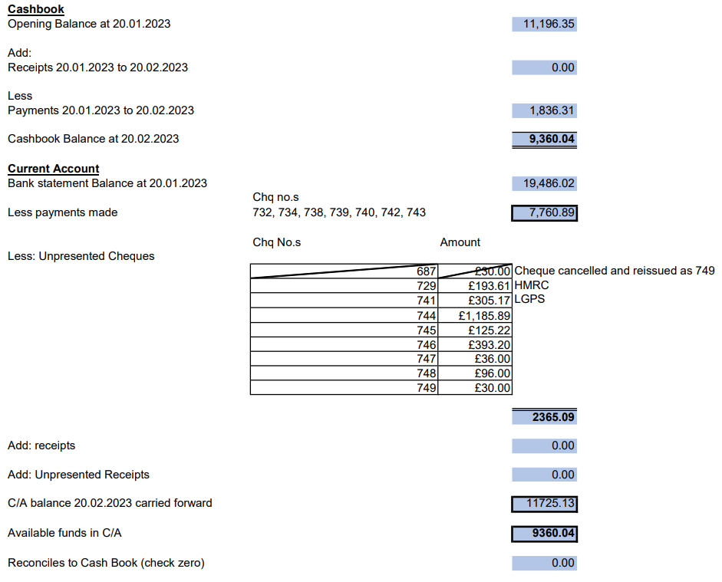

- Budget report for February 2023 – Resolved: unanimously approved.

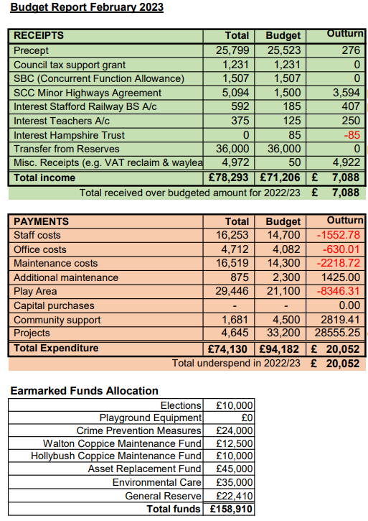

23/25 Planning
- To agree response to application 23/37140/PTEL - Telecoms monopole, Milford Road. Cllr Taylor had hoped that they would take a deeper look at the scheme this time, but it seemed to be the same application but moved across by 6 feet. Resolved: Cllr Taylor’s proposed response agreed – Clerk to send response to SBC. Action: Clerk
- To agree response to application 22/36826/FUL – 2 dog exercise fields off Holdiford Road. Cllr Taylor felt that the ‘deer fence’ needed more screening and suggested more landscaping in his draft response. Resolved: Cllr Taylor’s proposed response agreed – Clerk to send response to SBC. Action: Clerk
- To agree response to application 22/36547/HOU 11 Briar Close extension. Cllr Taylor had suggestion responding with no objection to this application. Resolved: Cllr Taylor’s proposed response agreed – Clerk to send response to SBC.

23/26 Other Meetings
- Environment Group – the group had not met since the last Parish Council meeting.
- Village Hall Council of Management – The Council of Management had not met since the last Parish Council meeting. It had been proposed that the Parish Council use the loft storage in the main Hall via a ladder rather than the large storage cupboard in the Bromage Room. Cllr Pearson said that she knew damp had been an issue up there in the past and to check that it had been resolved. Resolved: Council agreed to use the loft storage area. Action: Clerk

23/16 Agenda items for the next meeting

The next Berkswich Parish Council Meeting would take place on Tuesday 4 April 2023 at 7.30 pm at Walton (Berkswich) Village Hall. Agenda items agreed were: Cheque Signatories over Election Period.

Meeting closed at 8.20 pm.

