Local Government Act 1972

Notice of Annual Parish Meeting

For Berkswich Parish

All residents of Berkswich Parish are invited to the
Annual Parish Meeting
To be held on Tuesday 9 May 2023 at 7.00 pm
At Walton (Berkswich) Village Hall, Green Gore Lane,
Walton on the Hill

Agenda

23/1 Welcome and introduction by Chair

23/2 To receive apologies

23/3 To approve the minutes of the meeting held on 3 May 2022

23/4 To receive the Chair’s Annual Report 2022/23

23/5 To receive the Annual Financial Statement

23/6 To discuss matters raised by parishioners

23/7 Close of meeting

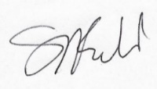
Sue Fullwood
Clerk/Responsible Financial Officer 19 April 2023

