BERKSWICH PARISH COUNCIL

Minutes of Berkswich Parish Council Meeting held on Tuesday 6 June 2023
at 7.30 pm at Walton Village Hall

Present: Cllr Alan Taylor (Chair), Cllr Sue Francis, Cllr Tim Luker, Cllr Caroline Pearson (Vice Chair), Cllr Michael Norris, Cllr Beverley Hughes, Cllr Vicky Campbell and Cllr Bob Gilson

In attendance: Cllr Peter Edgeller of Stafford Borough Council, Mrs Sue Fullwood as Clerk and three members of the public

Cllr Taylor welcomed everyone to the meeting.

1 Public session

- The first member of the public asked if a response had been received to the joint letter sent by Berkswich and Brocton Parish Councils to Staffordshire County Council (SCC) regarding a possible 30 mph limit on Brocton Road. No response had been received apart from the initial acknowledgement despite the Clerk chasing a response. Cllr Taylor felt it would be prudent to let SCC have another month to respond as they were under considerable work pressure and the Council did not want to become a nuisance. The member of the public felt that it taken him becoming a nuisance to get the former Chief Executive, John Henderson, to take action and he knew that County Cllr John Francis had been under the impression that the speed limit reduction had been passed. The member of the public felt really frustrated and that nothing would happen until there was a serious accident.

- All three members of the public wished to raise an issue about the group of families from the travelling community who had moved onto Milford Common on the evening of Saturday 3 June. Members of the group had stolen ice creams, money and a mobile phone, at least one member of the public had been threatened with physical violence and there were loose dogs attacking local dogs. They were putting off visitors to the Common and the car park was empty. The first member of the public had been campaigning for four years for the bunding and ditches to be refurbished around the Common. The three members of the public all asked for the Parish Council to support them in putting pressure onto Staffordshire County Council to get the bunding put back in as a matter of urgency. Cllr Taylor stated that he fully understood their concerns and sympathised. Cllr Edgeller suggested a contact from the Environment Team at SCC as someone to write to. Resolved: Clerk to write to the Environment Team and Cllr Francis would send a copy to the first member of the public.

- The second member of the public raised an issue about large lorries crossing the bridges at Holdiford Road, particularly Amazon lorries. They were causing big gouges in the road surface where the lorries were so long that they were grounding on top of the bridges. The only signage along there was a red sign through HGV. If the lorry drivers then decided not to go over the bridges, they were trying to turn around outside the cooling station. One nearby house had had its front wall knocked over during the night and the driver had driven away without leaving details. Resolved: The Council would write to Staffordshire Highways at SCC asking them to improve warning signage for HGVs in the area and to consider imposing a weight limit on Holdiford Road. Action: Clerk

The members of the public left the meeting at 7.50 pm.

23/66 Apologies – Received from Cllr Malcolm Millichap and Cllr Ann Millichap due to family business. Resolved: both apologies were noted.

23/67 To record Declarations of Interest regarding items on the agenda. None.

23/68 Minutes of the Council meeting held on 9 May 2023 – 23/47 Cllr Gilson said that he lived in Baswich, not Milford. Resolved: It was agreed that the minutes with suggested amendment were a true record of the meeting. Action: Clerk

23/69 Minutes of the Council meeting held on 22 May 2023 - Resolved: It was agreed that the minutes were a true record of the meeting.

23/70 Update on matters arising which were not agenda items
None.

23/71 Annual Governance & Accountability Return (AGAR)
- The Annual Internal Audit Report for 2022/23 was received and noted.
- The Annual Governance Statement 2022/23 was approved and signed by the Chair and the Clerk/RFO.
- The Accounting Statements for 2022/23 were approved and signed by the Chair and the Clerk/RFO.
Cllr Francis thanked the Clerk/RFO for all her work on the audit. Notices would be published on 7 June and the period for the exercise of public rights would run from 8 June to 19 July 2023.

23/72 Issues around Walton Garage
Along with the issue of the transporters regularly delivering vehicles to the site, the graffiti on the site was becoming a problem. Resolved: the Clerk to write to the owners of the site and to the current operators W R Davies expressing concerns about unneighbourly practises. Action: Clerk

23/73 Road surface on Kitlings Lane
. Cllr Gilson felt that the road surface was getting worse from the top of Kitlings Lane down as far as the church car park. It was becoming dangerous for pedestrians as there weren’t any footpaths. Resolved: Clerk to write to Highways at SCC asking them to improve the road surface. Action: Clerk

23/74 Chicken Run Maintenance
Following discussion it had been established that the Council were responsible for the maintenance of the hedge and wall along the “Chicken Run”. Resolved: TGM to be asked to look at where the hedge is bowing out. Action: Clerk Concerns were raised about the wall listing to one side and Cllr Taylor reassured Council that he had assessed it and felt it wasn’t in danger of collapse.

23/75 Rescheduling of Summer Event
It was felt that a rescheduled event would be just as likely to be cancelled due to inclement weather as the original. Resolved: Event not to be rescheduled.

23/76 Berkswich Parish Fete - Resolved: The Council would have a stall at the fete and give out the supplies bought for the cancelled Coronation Picnic to children attending. Clerk to book a stall and ask to borrow a table. The Fete starts at 1.30 pm and Cllr Taylor and Cllr Pearson would meet at the Cricket Club at 11.30 am to put up the gazebo.

23/77 Dignity at Work Policy – This NALC policy was to replace the previous Antibullying and Harassment Policy. Resolved: Cllr Francis proposed that the policy was approved and this was seconded by Cllr Luker. Agreed unanimously.

23/78 Financial Matters:
- Bank Reconciliation and expenditure for May 2023. The PDF did not show the final column for the expenditure, therefore item deferred until July meeting.

- Budget Report for May 2023. Resolved: unanimously approved.

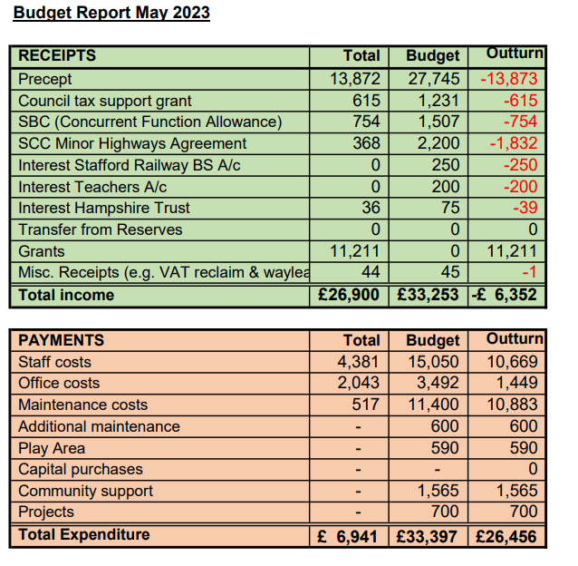

23/79 Planning Matters
- Response to application 23/37459/HOU 20 Oak Avenue - Resolved: The application was identical to an application in 2020 which had been refused. The Council had no objection in principle but would advise changes to the design. Action: Cllr Taylor and Clerk
    - Response to application 23/37447/HOU at 28 Kitlings Lane – Resolved: The Council had no objection in principle but would advise that the garage was removed from the application. Action: Cllr Taylor and Clerk

23/80 Reports from other Meetings
- Environment Group – The Farming in Protected Landscapes Officer from SCC had looked at the management plans for Walton Coppice produced by Staffs Wildlife Trust and Keysor’s. He had advised that he could support a bid for hedgerow around the Western side of the coppice and for some additional work in the main coppice. Resolved: Cllr Luker to set up a meeting of the Environment Group (all welcome) with the aim of getting an application ready for the FiPL panel on 23 August. Cllr Francis thanked Cllr Luker for his work in this area.
A homeowner from Bluebell Hollow had complained that brambles were growing through his fence into his garden. He had been advised that he was legally entitled to cut anything that grew over onto his property.
- Village Hall Council of Management – Cllr Pearson had sent apologies and had not received the minutes.

Agenda Items for the Next Meeting
The next meeting of the Parish Council will take place on Tuesday 4 July 2023 at 7.30 pm in the Bromage Room at Walton Village Hall. Agenda items agreed were: Finance – resources and barriers; the phone box.

The meeting closed at 8:40 pm.

