BERKSWICH PARISH COUNCIL

Minutes of Berkswich Parish Council Meeting held on Tuesday 5 March 2024
at 7.30 pm at Walton Village Hall

Present: Cllr Alan Taylor (Chair), Cllr Caroline Pearson (Vice Chair), Cllr Sue Francis, Cllr Tim Luker, Cllr Malcolm Millichap, Cllr Ann Millichap, Cllr Bob Gilson, Cllr Michael Norris, Cllr Beverley Hughes, and Cllr Vicky Campbell.

In attendance: Three members of the public and Mrs Sue Fullwood as Clerk.

Cllr Taylor welcomed everyone to the meeting.

1 Public session

a Articulated Lorries Damaging verges near Milford Common

The first member of the public raised the issue of 40-ton articulated lorries entering and leaving R&J Aggregates at The Green. The lorries were damaging the grass verges on the edge of The Green when entering their leased site and the corner of Brocton Road when leaving the site to return to their sales area at Brocton Business Park. The member of the public circulated photos of both areas of damage. There were never any problems when H Nickolls & Son were operating from the site, but the drivers from R&J Aggregates don’t seem interested in caring for the village. They were driving over the service manholes which were now uncovered. The first member of the public said that tractors and other agricultural vehicles could be responsible for some of the damage on the corner of Brocton Road, but the damage to The Green was solely from R&J. Cllr Taylor responded that councillors would view the damage for themselves and if they felt that the damage caused warranted it, the Clerk would contact Staffordshire County Council as the Highways Agency and R&J Aggregates expressing concern at what is happening there. Cllr Norris added that he suspected that Nickolls’ drivers had waited for the road to be clear before turning so that they could go onto the other side of the road. Action: Cllrs/Clerk

b Speed Sensors around Milford Common

The first member of the public informed the Parish Council that Milford Common had a new site manager and they were making plans including finishing off the ditch and bunding, installing wooden bollards, planting trees and were considering a height restriction at the entrance to the car park. The member of the public had met the site manager and County Councillor John Francis on site to discuss the proposed changes. The reduced speed limit to 30mph on Brocton Road was due to be implemented by the end of February, but work hadn’t yet started. The member of the public asked if the Parish Council would consider installing speed warning sensors along Brocton Road.

c HGVs using Bridges on Holdiford Road

The second member of the public said that there were a lot of HGVs going over the bridges and they were shaking their home when they passed so they must be damaging the bridges including the Grade II listed Holdiford Bridge. Both bridges were in need of repair and some of the stones on the top of the canal bridge had been loosened and could be dangerous for people passing under the bridge. The canal bridge also had gouges in the surface where long vehicles were grounding on the top. Blue signage near the bridges said that the road was unsuitable for vehicles over 7.5tn, but it was only advisory. Resolved: Cllr Taylor would inspect the bridges himself and then ask the Clerk to write to Highways at SCC asking for a weight limit to be put on. Action: Cllr Taylor/Clerk

24/23 Apologies – Apologies were received from Cllr Peter Edgeller of Stafford Borough Council as he was at an SBC meeting.

24/24 To record Declarations of Interest regarding items on the agenda. None.

24/25 Minutes of the Council meeting held on 6 February 2024 – Resolved: It was agreed that the minutes were accurate. Re item 24/13, Cllr M Millichap informed the council that he had contacted the person from the Phoenix Military History group and said that the event would not be going ahead and thanked him for his interest.

24/30 Lighting Issues at Dora Rose Nursing Home
This item was moved up the agenda so that the three members of the public could be in attendance. Cllr Taylor had visited the site in the dark and had been astonished at the way it was lit up. Planning permission had been given for 5 permanent lighting columns that the light would not spread from, but they were lots of different lights set up. Staff at Dora Rose had said that they had received lots of complaints from visitors to the home who said that they couldn’t see at night. The staff were aware of issues with the neighbours regarding lighting and said that staff from the head office in Birmingham were liaising with SBC about the planning conditions. Cllr Taylor had contacted the planning team at SBC who had said they were unaware of any discussions about the Home. The Clerk had written to the SBC enforcement team expressing concern that the lighting was not in accordance with planning conditions and the issue was now in their hands.

The three members of the public left the meeting at 8.07pm.

24/26 Clerks Report for February 2024
In consultation with the Chairman, the Clerk had agreed to prepare a monthly report detailing work undertaken on behalf of the Council that was not already on the agenda. A discussion took place around whether Matters Arising should form part of the agenda and Cllr Pearson clarified that the Good Councillors’ Guide confirmed that they shouldn’t. Cllr M Millichap thanked the Clerk for her work on the issues with WR Davies.

24/27 Defibrillator Grant Application
The Methodist Church should be asked to complete a formal application form if they wished to continue to apply for funding for a defibrillator. Action: Clerk

24/28 Possible use of Walton Coppice by the Scouts
The local Scout group had emailed a letter to Cllr Taylor that day offering to help maintain Walton Coppice and asking if they could use it for nature walks and den building. Cllr Francis expressed concerns about them using the whole site and being allowed to disturb wildlife. Cllr Luker said that there were ways around that such as restricting access during the breeding season from March to May. Cllr Norris said that caution should be given to allowing Scouts to use the site, but not anyone else, it could be setting a precedent. He also felt that the Council should see evidence of Risk Assessments and insurance cover. The Clerk would share the email from the Scouts with the rest of the Council. Action: Clerk

24/29 Waste Bin Sites Within the Parish
The Clerk had obtained a list of waste bins in the parish from Streetscene at SBC and plotted them onto a map. Cllr Taylor felt that giving SBC a list of places where we would like bins would be better than lots of individual contact and suggested that this item be considered at the next meeting. Clerk to ask for suggestions from residents on Facebook and in the Spring Newsletter. Action: Clerk

24/30 Lighting Issues at Dora Rose Nursing Home (see above).

24/31 Financial Matters:
- Bank Reconciliation and Expenditure for February 2024 – Resolved: The bank reconciliation and expenditure were unanimously approved.

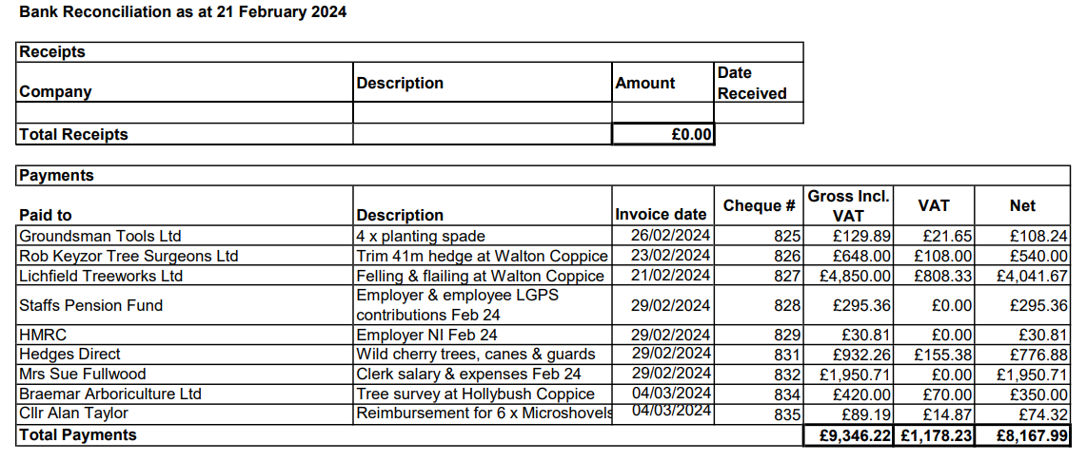

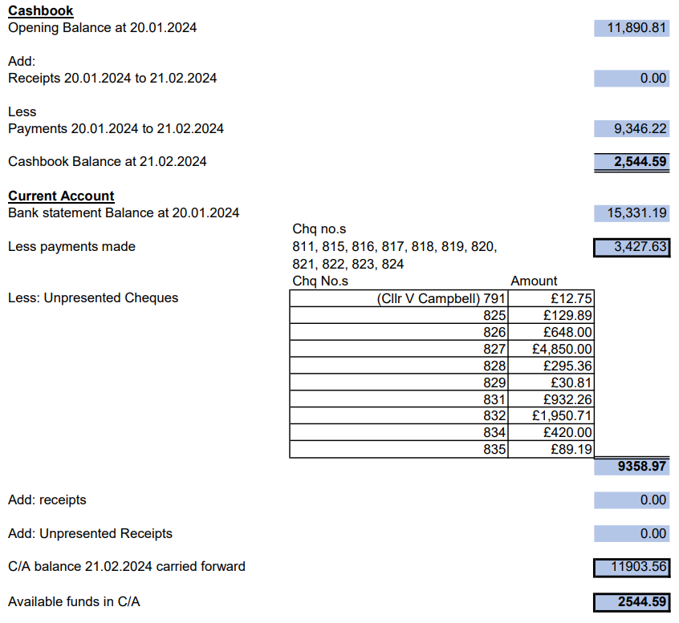
ii Budget Report for February 2024 - Cllr M Millichap asked the Clerk to calculate exactly how much money was owed to HMRC for the VAT that should not have been reclaimed and to add a footnote to the report stating how much grant funding was still outstanding. Action: Clerk Resolved: the report was unanimously approved.
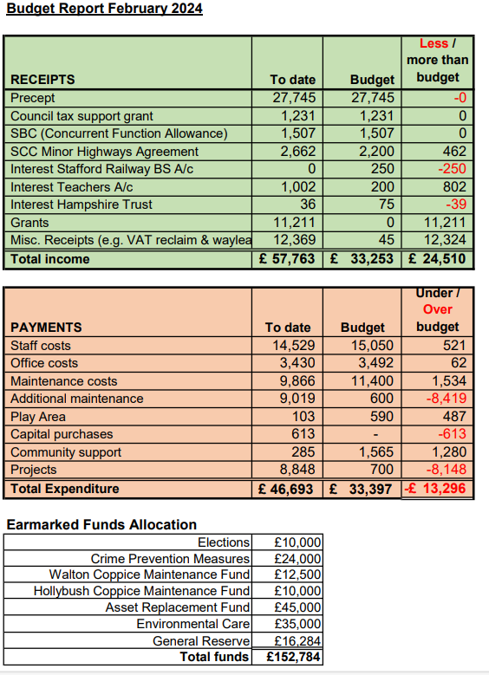
24/32 Reports from other Meetings
- Environment Group – Cllr Luker reported that the second working party held on 3 March at Walton Coppice had gone very well, but it had been a long day, finishing at 4.30 pm. Around 30-40 Scouts had attended and they had done a great deal of work. Cllr Taylor, Cllr Luker and one other person had returned on the morning of 5 March to complete the planting and there were still quite a lot of plants left. Cllr Taylor added that the contracted tree surgeon had done an enormous amount of work for a limited budget. He had chopped down more trees than anticipated and opened up the coppice extraordinarily well. There was a lot more light getting to the gardens of the houses on Bluebell Hollow and the site looked a lot better. Cllr M Millichap asked for thanks to be recorded to the Environment Group and suggested that the Clerk should write to BCV and the Scouts thanking them for their contribution. Action: Clerk
- Village Hall Council of Management – Cllr Pearson reported that there had been no meeting in February. The AGM was scheduled to take place in March.

24/33 Agenda Items for the Next Meeting scheduled for Tuesday 2 April 2024 at 7.30 pm in the Main Hall, Walton Village Hall
Agenda items agreed were: defibrillator grant application; Parish Fete; Flower Beds on Main Road; waste bin sites; and data from SIDs.

The meeting closed at 8:50 pm.

