Local Government Act 1972

Notice of Annual Parish Meeting

For Berkswich Parish

All residents of Berkswich Parish are invited to the
Annual Parish Meeting
To be held on Tuesday 7 May 2024 at 7.00 pm
At Walton (Berkswich) Village Hall, Green Gore Lane,
Walton on the Hill

Agenda

24/1 Welcome and introduction by Chair

24/2 To receive apologies

24/3 To approve the minutes of the meeting held on 9 May 2023

24/4 To receive the Chair’s Annual Report 2023/24

24/5 To receive the Annual Financial Statement

24/6 To discuss matters raised by parishioners

24/7 Close of meeting

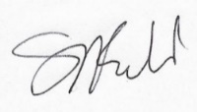
Sue Fullwood
Clerk/Responsible Financial Officer 9 April 2024

